CHG-MERIDIAN expands IT solutions for a strong employer brand
- Employer Benefit Solutions expand the IT solution portfolio for a strong employer brand
- Increase employee motivation: IT incentive programs for employees
- State-of-the-art technology for everyone, for at home, for the entire family

Weingarten, April 29, 2015

Company pension entitlements, child care, company car – there are many incentive programs for employee motivation. In practice, however, often only a few employees benefit from them. Because not everyone has children; not everyone has their own company car. Many employees end up missing out. Happily, the new 'employee PC program' (MPP) by CHG-MERIDIAN works differently. The financial and technology manager from Weingarten, southern Germany is thereby strategically expanding its offer in terms of its IT solution portfolio.

Employees have the opportunity to acquire state-of-the-art IT technology via their company for a reasonable price. And exclusively high-quality devices by renowned manufacturers: Smartphones, PCs, notebooks, tablets and accessories. The costs are met by the employees via deferred compensation. As the monthly payments for use of the devices are straightforward, this is of interest to all levels of income. All of this creates common ground and a sense of personal benefit, which increases employee acceptance of the HR measure. For many HR departments this is a real benefit because it is a question of sustainably and cost-effectively creating incentive systems.

Attractive for employees, cost neutral for employers
The financial and technology manager CHG-MERIDIAN unburdens the employee by taking on most of the administrative and organizational tasks. "The particular charm and uniqueness of the employee PC program is the clear win-win situation for all involved," explains Frank Kottmann, member of the board. "The employee receives devices with a high status value significantly below the usual market price. And the program is essentially cost-neutral to the employer. There are no notable costs in HR, IT or purchasing," continues Frank Kottmann.

The program is also elegant and straightforward for the employee: The device catalog is made available on a web-based communications platform. There the employee can find everything they need to know about the structure and process of the program. They can simply meet the monthly costs via deferred compensation. This also reduces their income tax burden – an effect that reduces costs. This is displayed in the web portal using a benefit calculator, so that they can see their advantage of the usual market price at a glance. All devices can be completely privately used by them and their family. In principle, the number of devices is not limited.

Generally, employees can place orders within two annual time windows. This time limitation lends the program an event-like character, which can be additionally accompanied with personnel marketing measures. Furthermore, the limited campaign time periods are to help prevent the feared dulling and habit effect in the incentive measures.

The measure for employee loyalty and motivation remains balance and cost-neutral for the employer. This is because the German government is supporting the private use of commercial communications technology in terms of taxation. It does this in order to contribute towards qualifying the people, family and children for the requirements of the information society. That's why there is no monetary benefit to assigning the communications devices, as their use is tax-free according to §3 no. 45 of the German Tax Code.

An overview of the Employer Benefit Solutions by CHG-MERIDIAN

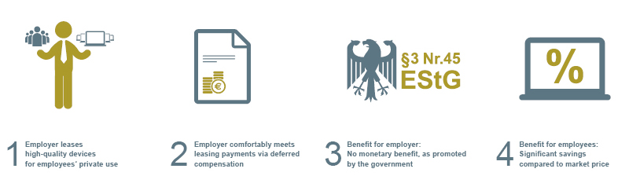

For more information, please visit: www.chg-meridian.com

CHG-MERIDIAN: The company
CHG-MERIDIAN is one of the world's leading non-captive providers of technology management in the fields of IT, industry, and healthcare. CHG-MERIDIAN has a workforce of approximately 850 professionals and offers one-stop management of customers' technology infrastructure. Its product range includes consulting, financial and operational services, as well as remarketing services for used equipment at its two proprietary Technology and Service Centers in Germany and Norway. CHG-MERIDIAN offers efficient technology management for large corporations, small and medium-sized enterprises, and public-sector clients. It provides services for over 10,000 customers around the world and manages technology investments in excess of €3.6 billion. More than 1,600 of its customers also monitor their technology portfolios online using the TESMA© Online technology and service management system. The company has a global presence with 40 branch offices in 23 countries and is headquartered in Weingarten, Southern Germany.

Efficient Technology Management ®

